#MedSafetyWeek Social Media Plan 2026
Table of Contents
Introduction 1
Goal 1
Objectives 1
Key messages 1
Social media posts 2
Audiences 2
Hashtags 3
Emojis 3
Carousels 3
Messaging apps 3
Other social media platforms 4
Influencer partnerships 4
Additional resources 5
FAQ 5
Visuals 6
Instagram 8
Facebook/LinkedIn 14
X 20
Supplementary posts 24
Polls 25
Instagram story quiz 26
Re-Posts 26
Old #MedSafetyWeek campaign materials 26
Content calendar 27

Introduction
This year we celebrate the eleventh annual #MedSafetyWeek. The Medicines Safety Week runs from 2 to 8 November with the goal to encourage everyone to report suspected side effects to medicines.
The 2026 edition of #MedSafetyWeek explores the theme ‘Side effects – don’t ignore them, report them.’ We’re pleased to welcome 139 organisations from 129 countries to this year’s global campaign.

Goal
Get patients and healthcare professionals to report suspected side effects of medicines.

Objectives
Setting clear objectives for your #MedSafetyWeek campaign helps monitor the overall performance on social media and yearly trends. You may choose to monitor social media metrics such as total impressions, unique impressions, total number of engagements and engagement rate, total number of clicks to your reporting system/linked material and click-through rate (CTR), change in total followers, or paid versus organic performance of metrics. Choose the metrics that matter most to your context and organisational goals, then set clear objectives to attain them. For instance, you may wish to improve organic impressions by 3.5% in 2026 compared to 2025.

Key messages
There are many kinds of side effects. Don’t ignore them – report them.

Reporting side effects helps to make medicines safer for everyone.

Patients, parents, and patient carers
There are many different types of side effects. Learn how to spot them and know where to report. Don’t ignore suspected side effects – report them and help protect others from harm.
Healthcare professionals
Engage with patients, parents/guardians, and carers to identify their concerns. Stay alert for suspected side effects at all stages of care and report them promptly. Don’t delay – each individual report helps gather more information about the safety of medicines.

Dealing with negative feedback online
Medicinal products can be a sensitive topic in the current climate and one that can open difficult conversations on social media.
If you decide to respond, carefully choose the comments you reply to. Do not respond to provocative messages as arguing with people who are abusive or hold radicalised opinions is likely to lead nowhere – don’t feed the trolls. It is better to spend your energy on people who seem to have genuine concerns or questions.
When responding, always provide factual, scientific information. Make sure that the information provided answers the question and does not raise any further doubts.

Keep in mind that many users do not comment/respond to content on social media. Your responses can help shape public opinion and positively impact those who ‘silently’ read, view, or share content.

Social media posts
The posts that follow are a suggestion. You may tweak them to fit character limits for each social media platform and your local circumstances or preferences.

#MedSafetyWeek partners are responsible for their own translations and all content they publish online.

Fill in the [highlighted sections] as appropriate and include links to your national reporting system.

If you are not a regulatory agency, or do not allow reporting online by patients and consumers, feel free to include a different link or a different call to action (e.g., report to your medicines regulator/local health authority/healthcare professional, via phone/email/other channel).

Audiences
The posts take into consideration the generic audience for each social media channel:

- Facebook: mainly people above 25 years old, e.g. patients, parents, carers, but also professionals
- Instagram: appeals mostly to users from 18 to 65 years old
- LinkedIn: aimed at the professional community, e.g. GPs, nurses, scientists, researchers, pharmacists, pharmaceutical industry, other healthcare professionals
- X: platform used by people from different backgrounds and ages, mostly above 25 years old
The tone of messages is similar across all platforms, with some posts aimed at targeted professional audiences. You are welcome to adapt the posts to each network if you feel you would like to target professionals or the public only.

Hashtags
Always include #MedSafetyWeek so that we can monitor our reach. We suggest additional hashtags below, but there might be others that are more relevant in your country or language:

#PatientSafety #ReportSideEffects #Pharmacovigilance

Emojis
Emojis can be a visual aid on social media to help get your message across. Be mindful of the innuendos associated with some emojis and how different skin tone options may be interpreted by your audiences. Test the ‘emoji meanings generator’ in the linked Hootsuite blog above if you are unsure.

Carousels
Most social media platforms allow for carousel-style posts, where the user can flip through a collection of images or videos in one post. Due to their design, these posts may boost user engagement among your audiences. You can read more about sharing these types of posts on LinkedIn, X, and Facebook (ads only).

Messaging apps
WhatsApp, Discord, and other group messaging services allow users to create topic-specific communities. These can be an effective way to share information with a large group of people that are interested in a common topic, such as #MedSafetyWeek or pharmacovigilance. Such services allow administrators to share announcements, keep members updated on the latest posts or services available, and engage in conversations with members. If these apps are popular in your region or with your audiences, you may want to consider expanding your #MedSafetyWeek campaign to these types of platforms.
You can easily share the Facebook/LinkedIn #MedSafetyWeek posts to these platforms, as well as all films and image cards. You will find guidelines for creating communities and posting at the links below:
- WhatsApp Communities
- Beginner’s Guide to Discord

Other social media platforms
While the social media plan only includes tailored posts for Instagram, Facebook/LinkedIn, and X, you are welcome to post #MedSafetyWeek content to other platforms. This includes, but is not limited to, Bluesky, Snapchat, Threads, TikTok, WeChat, and YouTube. Below is a suggestion for how the Social Media Plan can be repurposed for other platforms:
- Instagram posts can be repurposed for TikTok. See this article for video best practices on TikTok.
- Facebook/LinkedIn posts can be repurposed for YouTube. See this article for YouTube Shorts tips.
- X posts can be repurposed for Bluesky and Threads. See this link for the basics of Bluesky and this link for Threads.

Influencer partnerships
Today’s creator economy presents ample opportunity to partner with content creators and organisations to amplify messaging, reach new audiences, and co-create content for local contexts on social media. However, it is important to recognise that health communications should contain information that is trustworthy, evidenced-based, and accessible. This duty extends to the creators you partner with. Before partnering with a content creator, consider the following:
- Determine the type of health influencer they are (healthcare professional, patient advocate, lifestyle or wellness community). Determine if their medical expertise, personal experience, or qualifications validate their content. Survey their followers and following lists to determine if they mainly reach bot accounts, a political or niche subgroup, or genuine ‘average’ users.
- Examine the type of content they post. Are they looking to inform or persuade their audiences? Do they provide context when presenting complex terms and using plain language? Do they use symbols, phrases, or imagery that are affiliated with political movements? Do they share scientific literature or resources from peer-reviewed journals or credible institutions? Are they encouraging users to purchase a product?
- Set clear guidelines about the partnership and content. Co-create content to ensure messaging is in line with regulatory guidelines and current medical literature. Co-design messaging to ensure it matches your audience’s health literacy levels, is culturally relevant, and built for social media platforms. Clearly mark if the post is part of a paid partnership, using #ad or #sponsored in the text and media.

Please note that the partnership is between you (your organisation) and the creator. It is not between the #MedSafetyWeek campaign and the creator nor Uppsala Monitoring Centre and the creator.

Additional resources
Sharing valid information from trusted sources can help strengthen your campaign and increase uptake of #MedSafetyWeek messaging among your audiences. You may choose to link to these external publications or adapt some of their key messages to your own campaign. Please cite these resources if you use them:

- Factors associated with underreporting of adverse drug reactions by health care professionals: A systematic review update (García-Abeijon et al.)
- Factors associated with underreporting of adverse drug reactions by patients: a systematic review (Costa et al.)
- Trends in adverse drug reaction reporting in eight selected countries after the implementation of new pharmacovigilance regulation in 2012: a joinpoint regression analysis (Masiliūnienė, G., Stankevičius, E. & Kaduševičius, E)
- You and your prescribed medicines (National Institute for Health and Care Excellence, UK)
- Guidance on adverse drug reactions (Medicines and Healthcare Products Regulatory Agency & YellowCard, UK)
- A beginner's guide to PV (Uppsala Monitoring Centre)
- Under-reporting of adverse drug reactions: A systematic review (Hazell L. & Shakir, S.)
- WHO briefing note: Safety of medicines – adverse drug reactions (World Health Organization)

FAQ

- Why do I need to include the #MedSafetyWeek hashtag in my organisation’s posts?
  - We use a third-party app to monitor the use of the hashtag throughout the campaign. By always including the #MedSafetyWeek hashtag in your posts, we can more accurately measure the reach of the campaign.

- Can I replace the #MedSafetyWeek hashtag with my local language?
  - Please ensure you always write #MedSafetyWeek in English. You are welcome to translate the campaign name to your local language, but you must always include the English hashtag #MedSafetyWeek in your posts. This ensures we can accurately track the campaign.

- Do I need to share all campaign materials on my organisation’s channels?
  - While we encourage participants to share all materials on their channels, we understand that your communication capacities may vary. At the minimum, please try to share the custom animations. You can repost #MedSafetyWeek content from UMC’s main social media profiles throughout the campaign or other #MedSafetyWeek materials that participating organisations share on their channels. You are also welcome to post additional content not included in the campaign package; we love to see what our partners create online and in person!

- The social media platforms that my organisation uses are not listed in the Social Media Plan. What should I do?
  - We recommend repurposing the social media posts to the platforms your organisation has a presence on. The social media cards and animations are designed to be mobile phone friendly, and the text in the suggested posts can be easily adapted to different platforms. See section ‘Other social media platforms’ listed above.

- Do you provide translations of the social media posts?
  - No. Participating organisations are responsible to translate the suggested posts in the Social Media Plan to their local language(s).

Visuals
Custom versions of films 1–2 will be delivered separately.

All other visuals are available in the graphics section of the campaign package, including text-free versions so that non-English speaking organisations can add their own translations.

Cards 1–3 are also available as Instagram story cards, with space to include a URL and hashtag sticker.

Card 1 | Get ready | 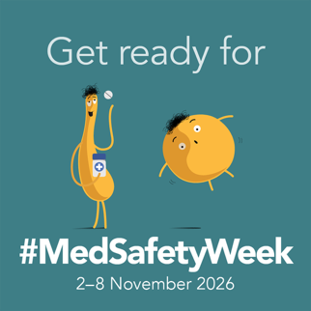
Card 2 | Hey, it’s | 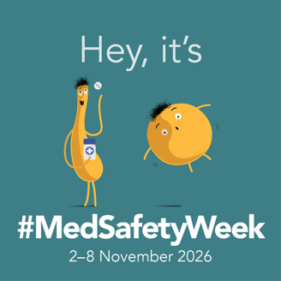
Card 3 | Thanks | 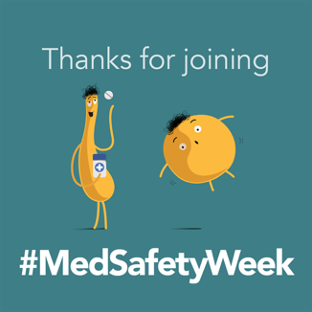
Film 1 | Change | 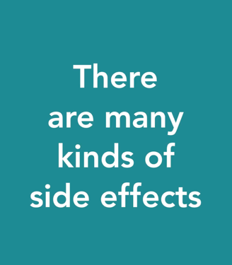
Film 2 | Square | 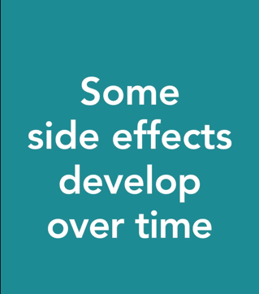
Film 3 | Campaign library | 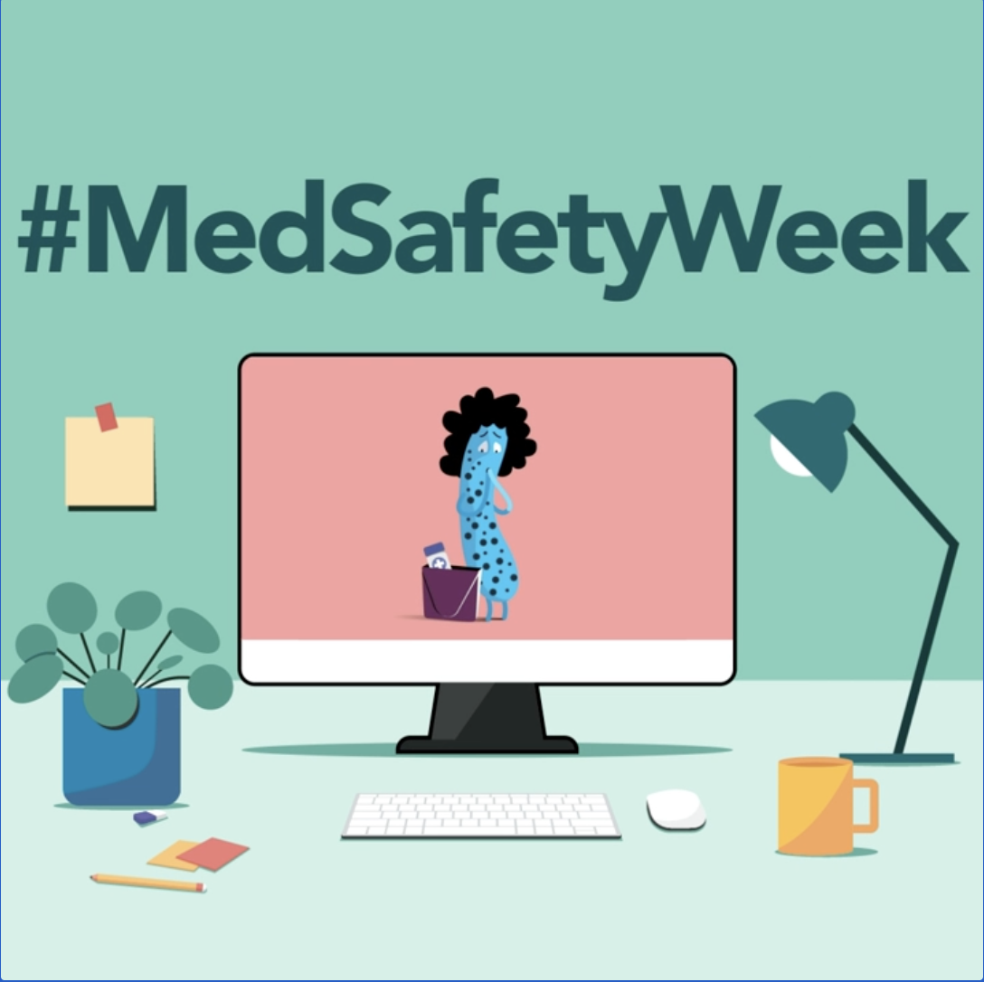
Carousel 1, alt card 4 | Look
Carousel 2, alt card 5 | Time
Carousel 3, alt card 6 | What changed
Carousel 4, alt card 7 | Care

Instagram

Post 1: (Card 1: Get Ready, Audience: General)
📆 Join us next week for #MedSafetyWeek!
129 countries 🌎 will join forces to help spread the word about the importance of reporting suspected side effects from medicines.
Let’s help make medicines safer for everyone. Learn how you can join the campaign at the link in our bio 🔗

Post 2: (Film 3, Campaign Library, Audience: General)
We're counting down to #MedSafetyWeek 2026 – join us! ⏱️
Anyone with an interest in medicines safety can support the campaign, including healthcare professionals, patient organisations, and regulatory agencies. Together, we can raise awareness of how reporting suspected side effects helps to make medicines safer for everyone.
Share our posts or visit the link in our bio to download campaign materials, including animations and social media assets.
Join the conversation from 2–8 November and help us spread the word and make a difference in patient safety
Post 3: (Card 2: Hey, It’s, Audience: General)
📣 #MedSafetyWeek starts today!

There are many kinds of side effects. No matter how they appear, side effects should not be ignored. Learn how to spot them and report to a healthcare professional or [national medicines regulator/reporting system].

Help us spread the word and improve patient safety – visit the link in our bio to learn more 🔗

#ReportSideEffects #PatientSafety
Post 4: (Film 1: Change, Audience: Patients)
There are many kinds of side effects. Don’t ignore them, report them ✅
Some side effects may appear as common symptoms, such as a headache or rash, while others may be more serious. Some are easy to spot, while others may not be visible to the eye.

If the symptom is new, unusual, persistent, or starts after beginning, changing, or stopping a medicine, don’t ignore it – report it and talk to a healthcare professional.

Click the link in our bio to learn how you can report to [reporting system] and help keep others safe from future harm 🔗

#MedSafetyWeek #ReportSideEffects #PatientSafety

Post 5: (Film 2: Square, Audience: Patients)
Some side effects develop over time. Don’t ignore them, report them ️✅

Some side effects may only develop after using a medicine for a long time. Others may not appear until after you've stopped treatment, changed dose, or started taking more than one medicine.

Whether side effects appear quickly or after a longer period, don’t ignore them – report them to [reporting system] and talk to a healthcare professional.

Your report matters for the safety of patients everywhere. Learn more at the link in our bio 🔗

#MedSafetyWeek #ReportSideEffects #PatientSafety

Post 6: (Film 1 or 2, Audience: Healthcare professionals)
A patient’s concern can be the first clue to a suspected side effect. What patients, parents, and carers describe may help identify a possible problem with a medicine.
Every interaction with a patient is an opportunity to detect, assess, and report suspected side effects. Stay alert to changes in symptoms, ask questions, and report what you observe ✅
Join the #MedSafetyWeek cause – visit the link in our bio for more 🔗
#ReportSideEffects #PatientSafety #pharmacovigilance

Post 7: (Film 1 or 2, Audience: Healthcare professionals)
There are many kinds of side effects. How they appear may depend on the patient in front of you.
If you’re a healthcare professional, take extra care with:
👦🏾 Children
👵🏻 Older adults
🏽 Pregnant or breastfeeding women
😷 Immunocompromised
These groups may require additional monitoring and assessment when it comes to using medicines. By staying vigilant and reporting suspected side effects, you can help strengthen medicines safety for all.
Don’t ignore side effects, report them ✅
#MedSafetyWeek #PatientSafety #ReportSideEffects

Post 8: (Film 1 or 2, Audience: Patients)
💬 Have you ever thought, “it’s only a rash,” “I’m just stressed,” or “it’s probably nothing” while using a medicine?

Common symptoms such as a rash, increased heart rate, or fatigue can all be side effects to medicines. Don’t dismiss symptoms because they go away on their own, appear later than expected, or start after treatment stopped.
Any symptom that is new, unusual or concerning is important to report. Talk to a healthcare professional and report to [reporting system].

Don't ignore side effects – visit the link in our bio to learn more 🔗
#MedSafetyWeek #ReportSideEffects

Post 9: (Film 1 or 2, Audience: General)
Every report of a suspected side effect to a medicine submitted to [reporting system] helps us learn more about that medicine’s safety. Reports ensure that [we] and other healthcare stakeholders can investigate the suspected side effect and, when necessary, take appropriate action to keep patients safe from future harm.

Click the link in our bio to find out how you can #ReportSideEffects 🔗
#MedSafetyWeek #PatientSafety #pharmacovigilance

Posts 10–13 can be shared as a carousel post or as a single post with the corresponding card. You will find instructions for sharing carousel posts at the top.
Post 10: (Carousel 1 alt Card 4: Look, Audience: Patients)
👀 What do side effects look like?
Some may appear as:
→ Skin changes
→ Stomach or digestion problems
→ Sleep or mood changes
→ Breathing or heart symptoms
→ Changes identified through tests
As a patient, parent, or caregiver, knowing how side effects may appear can help you spot them. Read the patient information leaflet supplied with the medicine and talk to a healthcare professional about new, unusual, or persistent symptoms.
Don’t ignore side effects – report them. Learn more at the link in our bio 🔗
#MedSafetyWeek #PatientSafety

Post 11: (Carousel 2 alt Card 5: Time, Audience: Patients)
⏰ When do side effects appear?
Not all of them appear right away. Some may develop:
→ After long term use
→ After changing dose
→ After stopping treatment
→ After using more than one medicine
→ After taking food, supplements, or herbal products
Be alert for new, unusual, or persistent symptoms while using medicines. If you think that you or someone you’re caring for is experiencing a side effect, don’t ignore it – report it to [reporting system] and talk to a healthcare professional.
Visit the link in our bio for more 🔗
#MedSafetyWeek #ReportSideEffects #PatientSafety

Post 12: (Carousel 3 alt Card 6: What changed, Audience: Healthcare professionals)
What changed, and when? This simple question can help you spot suspected side effects
If you’re a healthcare professional, stay alert to your patient’s symptoms or changes during treatment and consider:

→ Was a medicine started, stopped, or changed?
→ Could there be an interaction?
→ Could there be batch issues?
→ Are the symptoms unusual or persistent?
→ Were there abnormal test results?
→ Could it be toxicity or treatment failure?

Your expertise can help recognise suspected side effects that might be overlooked. Don’t ignore side effects – report them and help make medicines safer for all ✅

#MedSafetyWeek #PatientSafety #pharmacovigilance

Post 13: (Carousel 4 alt Card 7: Care, Audience: Healthcare professionals)
If you’re a healthcare professional, take the opportunity during these key moments in care to discuss and spot side effects:
→ Prescribing
→ Dispensing
→ Dose changes
→ Medicines review
→ Follow-up
→ Monitoring
→ Discontinuation
Every interaction with patients, parents, and carers is a chance to spot and report side effects. Don’t ignore them, report them ✅
Join the #MedSafetyWeek cause – visit the link in our bio for more 🔗
#ReportSideEffects #PatientSafety #pharmacovigilance

Post 14: (Card 3: Thanks, Audience: General)
That’s a wrap on this year’s #MedSafetyWeek campaign! 🎉
Thanks for following our channels this week as we highlighted the many ways in which side effects can appear and the importance of reporting them to [reporting system].
But the work doesn’t stop here – [your agency] will continue to collect and monitor reports of suspected side effects from patients and healthcare professionals to ensure medicines are used safely.
Remember that every report counts when it comes to the safety of medicines and patients worldwide.
Continue to #ReportSideEffects and help us make medicines safer ✅

Facebook/LinkedIn

Post 1: (Card 1: Get ready, Audience: General)
📆 Join us next week for #MedSafetyWeek!
129 countries 🌎 will join forces to help spread the word about the importance of reporting suspected side effects from medicines.
Let’s help make medicines safer for everyone. Learn how you can join the campaign
[link]

Post 2: (Film 3: Campaign library, Audience: General)
We're counting down to #MedSafetyWeek 2026 – join us! ⏱️
Anyone with an interest in medicines safety can support the campaign, including healthcare professionals, patient organisations, and regulatory agencies. Together, we can raise awareness of how reporting suspected side effects helps make medicines safer for everyone.
Join the conversation from 2–8 November – share our posts or download campaign materials, including animations and social media assets, to help us spread the word here https://who-umc.org/medsafetyweek-assets/

Post 3: (Card 2: Hey, it’s, Audience: General)
📣 #MedSafetyWeek starts today!

There are many kinds of side effects. No matter how they appear, side effects should not be ignored. Learn how to spot them and report to a healthcare professional or [national medicines regulator/reporting system].

Help us spread the word and improve patient safety. Learn more here [link]
#ReportSideEffects #PatientSafety

Post 4: (Film 1: Changes, Audience: Patients)
There are many kinds of side effects. Don’t ignore them, report them ✅
Some side effects may appear as common symptoms, such as a headache or rash, while others may be more serious. Some are easy to spot, while others may not be visible to the eye.

If the symptom is new, unusual, or persistent, don’t ignore it – report it and talk to a healthcare professional.

Learn how you can report to [reporting system] and help keep others safe from future harm at this link [link]

#MedSafetyWeek #ReportSideEffects #PatientSafety

Post 5: (Film 2: Square, Audience: Patients)
Some side effects develop over time. Don’t ignore them, report them ️✅

Some side effects may only develop after using a medicine for a long time. Others may not appear until after you've stopped treatment, changed dose, or started taking more than one medicine.

Whether side effects appear quickly or after a longer period, don’t ignore them – report them to [reporting system] and talk to a healthcare professional.

Your report matters for the safety of patients everywhere. Learn more here [link]

#MedSafetyWeek #ReportSideEffects #PatientSafety

Post 6: (Film 1 or 2, Audience: Healthcare professionals)
A patient’s concern can be the first clue to a suspected side effect. What patients, parents, and carers describe may help identify a possible problem with a medicine.

Every interaction is an opportunity to detect, assess, and report suspected side effects. Stay alert to changes in symptoms, ask questions, and report what you observe ✅

Join the #MedSafetyWeek cause – visit this link to find out how [link]

#ReportSideEffects #PatientSafety #pharmacovigilance

Post 7: (Film 1 or 2, Audience: Healthcare professionals)
There are many kinds of side effects. How they appear may depend on the patient in front of you.
If you’re a healthcare professional, take extra care with:
👦🏾 Children
👵🏻 Older adults
🏽 Pregnant or breastfeeding women
😷 Immunocompromised
These groups may require additional monitoring and assessment when it comes to using medicines. By staying vigilant and reporting suspected side effects, you can help strengthen medicines safety for all.
Don’t ignore side effects – report them ✅
#MedSafetyWeek #PatientSafety #ReportSideEffects #pharmacovigilance

Post 8: (Film 1 or 2, Audience: Patients)
💬 Have you ever thought, “it’s only a rash,” “I’m just stressed,” or “it’s probably nothing” while using a medicine?

Common symptoms such as a rash, increased heart rate, or fatigue can all be side effects to medicines. Don’t dismiss symptoms because they go away on their own, appear later than expected, or start after treatment stopped.
Any symptom that is new, unusual, or concerning is important to report. Talk to a healthcare professional and report to [reporting system].

Don't ignore side effects – learn why here [link]

#MedSafetyWeek #ReportSideEffects

Post 9: (Film 1 or 2, Audience: General)
Every report of a suspected side effect to a medicine submitted to [reporting system] helps us learn more about that medicine’s safety. Reports ensure that [we] and other healthcare stakeholders can investigate the suspected side effect and take appropriate action, if necessary, to keep patients safe from future harm.

Learn how you can #ReportSideEffects here [link]

#MedSafetyWeek #PatientSafety

Posts 10–13 can be shared as a carousel post or as a single post with the corresponding card. You will find instructions for sharing carousel posts at the top.

Post 10: (Carousel 1 alt Card 4: Look, Audience: Patients)
👀 What do side effects look like?
Some may appear as:
→ Skin changes
→ Stomach or digestion problems
→ Sleep or mood changes
→ Breathing or heart symptoms
→ Changes identified through tests
As a patient, parent, or caregiver, knowing how side effects may appear can help you spot them. Read the patient information leaflet supplied with the medicine and talk to a healthcare professional about new, unusual, or persistent symptoms.
Don’t ignore side effects – report them. Find out how here 👉 [link]
#MedSafetyWeek #PatientSafety

Post 11: (Carousel 2 alt Card 5: Time, Audience: Patients)
⏰ When do side effects appear?
Not all of them appear right away. Some may develop:
→ After long term use
→ After changing dose
→ After stopping treatment
→ After using more than one medicine
→ After taking food, supplements, or herbal products
Be alert for new, unusual, or persistent symptoms while using medicines. If you think that you or someone you’re caring for is experiencing a side effect, don’t ignore it – report it to [reporting system] and talk to a healthcare professional.
Read more [link]
#MedSafetyWeek #ReportSideEffects #PatientSafety

Post 12: (Carousel 3 alt Card 6: What changed, Audience: Healthcare professionals)
What changed, and when? This simple question can help you spot suspected side effects

If you’re a healthcare professional, stay alert to your patient’s symptoms or changes during treatment and consider:

→ Was a medicine started, stopped, or changed?
→ Could there be an interaction?
→ Could there be batch issues?
→ Are the symptoms unusual or persistent?
→ Were there abnormal test results?
→ Could it be toxicity or treatment failure?

Your expertise can help recognise suspected side effects that might be overlooked. Don’t ignore side effects – report them and help make medicines safer for all ✅

#MedSafetyWeek #PatientSafety #pharmacovigilance

Post 13: (Carousel 4 alt Card 7: Care, Audience: Healthcare professionals)
🩺If you’re a healthcare professional, take the opportunity during these key moments in care to discuss and spot side effects:
✔️ Prescribing
✔️ Dispensing
✔️ Dose changes
✔️ Medicines review
✔️ Follow-up
✔️ Monitoring
✔️ Discontinuation
Every interaction with patients, parents, and carers is a chance to spot and report side effects. Don’t ignore them, report them ✅
Find out how you can join the #MedSafetyWeek cause here [link]
#ReportSideEffects #PatientSafety #pharmacovigilance

Post 14: (Card 3: Thanks, Audience: General)
That’s a wrap on this year’s #MedSafetyWeek campaign! 🎉
Thanks for following our channels this week as we highlighted the different ways in which side effects can appear and the importance of reporting them to [reporting system].
But the work doesn’t stop here – [your agency] will continue to collect and monitor reports of suspected side effects from patients and healthcare professionals to ensure medicines are used safely.
Remember that every report counts when it comes to the safety of medicines and patients worldwide.
Continue to #ReportSideEffects and help us make medicines safer ✅
Join the #MedSafetyWeek cause – #ReportSideEffects [link]

X

Post 1: (Card 1: Get ready, Audience: General)
📆 Join us next week for #MedSafetyWeek!
129 countries 🌎 will join forces to help spread the word about the importance of reporting suspected side effects from medicines.
Let’s help make medicines safer for everyone. Join the campaign 👉 [link]

Post 2: (Film 3: Campaign library, Audience: General)
The countdown is on to #MedSafetyWeek 2026 ⏱️

Anyone can support the campaign by sharing our posts or downloading campaign materials, including animations and social media assets.

Join the conversation from 2–9 November 💬

Access materials here 👉 https://who-umc.org/medsafetyweek-assets/

Post 3: (Card 2: Hey, it’s, Audience: General)
📣 #MedSafetyWeek starts today!

There are many kinds of side effects. No matter how they appear, side effects should not be ignored. Learn how to spot and report them to a healthcare professional or [national medicines regulator/reporting system].

Help us keep medicines safe. Read more 👉 [link]

Post 4: (Film 1: Changes, Audience: Patients)
There are many kinds of side effects. Don't ignore them, report them ✅
Some may appear as common symptoms, such as a headache or rash. While others may be more serious, easy to spot, or not visible.
#ReportSideEffects and talk to your healthcare professional.
#MedSafetyWeek

Post 5: (Film 2: Square, Audience: Patients)
Some side effects develop after using a medicine for a long time. Others may not appear until after you've stopped treatment, changed dose, or started taking more than one medicine.

Don’t ignore side effects – report them and talk to a healthcare professional ✅

#MedSafetyWeek

Post 6: (Film 1 or 2, Audience: Healthcare professionals)
A patient's concern can be the first clue to a suspected side effect 🔎

Every interaction is an opportunity to detect, assess, and report suspected side effects.

Stay alert to changes in symptoms, ask questions, and report what you observe ✅

#MedSafetyWeek #ReportSideEffects

Post 7: (Film 1 or 2, Audience: Healthcare professionals)
If you're a healthcare professional, take extra care with:

👦🏾 Children
👵🏻 Older adults
🤰🏽 Pregnant or breastfeeding women
😷 Immunocompromised

These groups may require additional monitoring while using medicines.

Don't ignore side effects – report them this #MedSafetyWeek ✅

Post 8: (Film 1 or 2, Audience: Patients)
💬 Ever thought "it's only a rash" or "I'm just stressed" while using a medicine?
Common symptoms like a rash, increased heart rate, or fatigue can all be side effects from medicines. Don't dismiss symptoms – talk to a healthcare professional and report them ✅

#MedSafetyWeek

Post 9: (Film 1 or 2, Audience: General)
Every report of a suspected side effect counts ✅

Your reports help [us] learn more about the safety of medicines so that we can take appropriate action when needed to keep patients safe from future harm.

#ReportSideEffects here 👉 [link]

#MedSafetyWeek

Posts 10–13 can be shared as a carousel post or as a single post with the corresponding card. You will find instructions for sharing carousel posts at the top.

Post 10: (Carousel 1 alt Card 4: Look, Audience: Patients)
👀 What do side effects look like?

→ Skin changes
→ Digestion problems
→ Sleep or mood changes
→ Breathing or heart symptoms
→ Changes identified through tests

As a patient, parent, or caregiver, knowing how side effects appear can help you spot them.

#MedSafetyWeek

Post 11: (Carousel 2 alt Card 5: Time, Audience: Patients)
⏰ When do side effects appear?

→ After long term use
→ After changing dose
→ After stopping treatment
→ After using more than one medicine
→ After taking food, supplements, or herbal products

Don't ignore them – #ReportSideEffects ✅

#MedSafetyWeek

Post 12: (Carousel 3 alt Card 6, Audience: What changed, Healthcare professionals)
🩺 If you're a healthcare professional, stay alert to your patient's symptoms or changes during treatment.

Your expertise can help recognise suspected side effects that might be overlooked.

#ReportSideEffects and help make medicines safer for all ✅

#MedSafetyWeek

Post 13: (Carousel 4 alt Card 7: Care, Audience: Healthcare professionals)
Healthcare professionals 🩺

Discuss and spot side effects during key moments in care such as prescribing, dispensing, or monitoring. Every interaction with patients, parents, and carers is a chance to be vigilant.

Don't ignore side effects, report them ✅

#MedSafetyWeek

Post 14: (Card 2: Thanks, Audience: General)
That's a wrap on this year's #MedSafetyWeek! 🎉

Thanks for following along as we highlighted the different ways in which side effects can appear and the importance of reporting them to [reporting system].

Continue to #ReportSideEffects and help us make medicines safer ✅

Supplementary posts

In addition to the posts above, you may want to use some of the supplementary posts below during #MedSafetyWeek. If you decide to use them, please schedule them after post 3, but before the last post of the week.

Polls
You can launch a poll on LinkedIn, X, Facebook groups, Facebook stories, and Instagram, but please bear in mind the following:

- Ensure you choose the social media channel that has the most active followers. The more followers, the more potential engagements.
- You can pin the poll to the top of your X page to increase impressions.
- X is the only platform where voting is anonymous.
- Questions should only allow for a yes/no or multiple-choice response. This reduces the opportunity for activists to exploit the poll to write invalid arguments, false information, and inappropriate speech.
- Adjust the suggested text to fit the character allowance of your chosen platform and the messages you wish to communicate.
- For polls 4 and 6, consider providing instructions on how to report side effects or link to the reporting scheme in your country.

1. Have you ever had a side effect after taking a medicine?
a. Yes
b. No

2. Have you ever reported a side effect from a medicine using [reporting system]?
a. Yes, for myself
b. Yes, for a patient
c. Yes, for family or a friend
d. No

3. Do you know where to report side effects of medicines?
a. Yes
b. No

4. In your opinion, which types of side effects should be reported?
a. Serious ones
b. New or unusual ones
c. All types

Instagram story quiz
You may choose to use the quiz option on Instagram instead, which provides users with the correct response. You’ll find a complete guide for Instagram sticker options here. You can adapt these suggestions to fit your local reporting context.

5. The patient information leaflet contains information on the known side effects of a medicine.
a. True
b. False

6. Do healthcare professionals in [your country] have a duty to report side effects?
a. Yes
b. No
c. It depends on the severity

7. Side effects can only appear after using a medicine for a long period of time.
a. True
b. False

Re-Posts

It is advisable to repost the provided content, to guarantee that more users see the messages. Preferably, repost at a different time of day than the original post, to get the attention of other users that missed your original post. You can also use the weekend to re-share some of the messages that were published during the week.

Old #MedSafetyWeek campaign materials

We encourage you to reshare animations, social media cards, polls, or other materials from previous campaigns that you feel are relevant to your audiences. Visit the campaign library to access publicly available materials.

Content calendar

We have not included a time for your posts, as the best time to publish might vary from organisation, country, or even social media channel. We advise you to check your metrics to determine the best time to post. You can schedule posts ahead of time natively in Facebook, LinkedIn, and X, or use a scheduling assistant like Hootsuite or Sprout Social.

Teasers

 | 26-Oct  Mon | 30-Oct  Fri
Message | Post 1 | Post 2
Visual | Card 1 | Film 3

Campaign week

 | 02-Nov  Mon | 03-Nov  Tues | 04-Nov  Wed | 05-Nov  Thurs | 06-Nov  Fri | 07-Nov  Sat | 08-Nov  Sun
First  Message | Post 3 | Post 5 | Post 6 | Post 11 | Post 8 | Post 9 | Post 14
Visual | Card 2 | Film 2 | Film 1 or Film 2 | Carousel 2 alt card 5 | Film 1 or Film 2 | Film 1 or Film 2 | Card 3
Second Message | Post 4 | Post 12 | Post 10 | Post 7 |  | Post 13
Visual | Film 1 | Carousel 3 alt card 6 | Carousel 1 alt card 4 | Film 1 or Film 2 |  | Carousel 4 alt card 7

Please Note:
You may fill any other empty slots in the calendar with assets of your choice: you can post the films again, your own cards made with the illustrations in the campaign package, photos or videos from in-person events, or other visuals you may have developed to encourage reporting.

Good luck and remember – always include the #MedSafetyWeek hashtag! 😊

